**Lesson 7 Andreu Mut Portes L1G1**

* Today’s lesson activities will be done autonomously while I call you to do the speaking practice with me.
* Do the activities on this document and upload it on POLIFORMAT – TAREAS.
* Deadline: During today’s class time

**Practice 7 – Robots**

**PART 1**

**Listening – (This task will be part of your evaluation)**

You’re going to watch two videos about robots**.** You will watch the videos twice.

**1. Watch the video and answer the questions according to the video.**

Will robots take our jobs? | CNBC Explains

1. **What is a humanoid robot**?

It is a robot that looks, acts and talks as a human.

1. **In which places can we see robots today in our daily lives**?

We can see them in grocery stores, in the highway (driving cars) or at the theater.

1. **Which jobs are at high risk of being occupied by robots?**

They will be used in repetitive and predictable tasks. Such as transport or logistics.

1. **What are the advantages of using robots at work**?

They don’t become ill or need vacations.

1. **Which sectors will need more workers as a result of automation**?

Robot programmers, IT,customer service and advanced manufacturing.

1. **What human characteristics can’t robots replicate**?

They can’t replicate empathy or compassion for example.

1. **What type of workers will be especially affected if robots are introduced in the workplace**?

Lower skill workers. These jobs will be replaced by robots and the workers will have problems to find and learn a new job.

1. **What is a must today if we want to stay in the work market**?

Skillstrainning will be required.

**2. Watch the second video and answer these questions:**

[**https://www.youtube.com/watch?v=W0_DPi0PmF0&ab_channel=CNBC**](https://www.youtube.com/watch?v=W0_DPi0PmF0&ab_channel=CNBC)

1. **According to David, in which fields/jobs can these robots be used**?

Healthcare, therapy, education and customer services applications.

1. **According to Sophia, how can she help humans**?

He can help humans in technology and environment field. She can act as an ambassador too.

1. **What things does Sophia hope to do in the future**?

She can change her face expressions, she cand remember conversations and see you through eyes cameras. Because of that, she will improve and become smarter, conscious and creative.

1. **What things does David think robots will be able to do in the future**?

He thinks robots will be part of our society n the future. They will be with us, play with us, teach us etc

Record a **2-MINUTE FLIPGRID** in which you summarise the content of BOTH videos and give your opinion on whether using robots at work will be a good idea or not. I’ll stop you after 2 minutes.

**Speaking Topic 7**

**PART 1. Discuss these topics in your groups. You have photos with ideas to ‘inspire’ you ;)**

Which tasks are going to be replaced by robots in the near future?

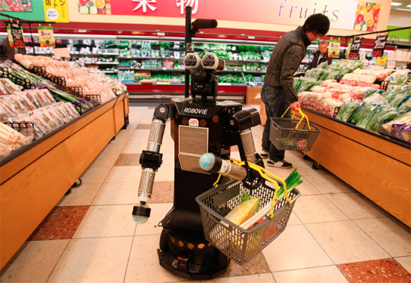 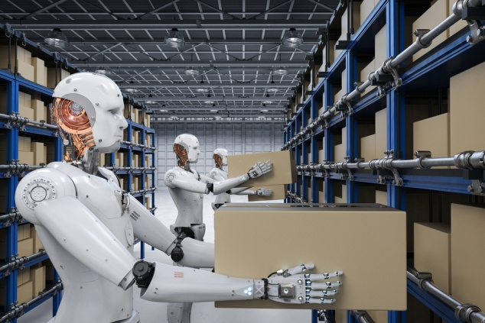

Would you like a robot to do the shopping for you?

How might the use of robots impact our daily routines in the future?

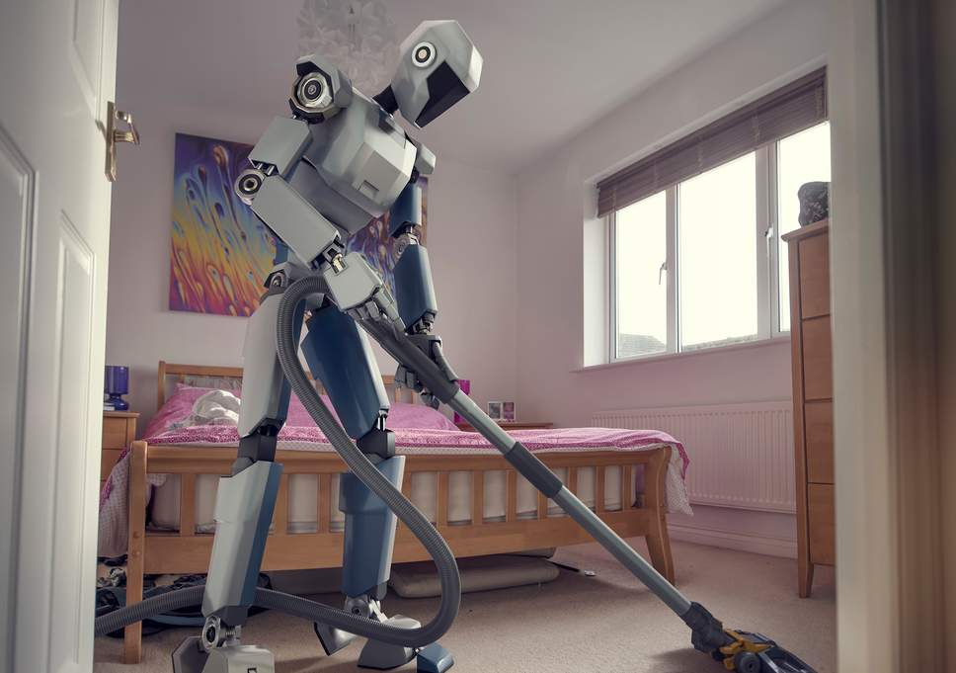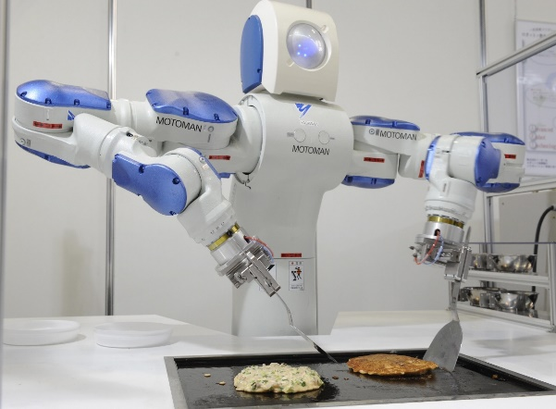

What housework task would you most like a robot to do for you? Why?

**PART 2. Discuss these topics in your groups. You have photos with ideas to ‘inspire’ you ;)**

What do you think are the advantages and disadvantages of using robots in these jobs?

Would you like to have a robot teacher or a robot doctor? Why / Why not? 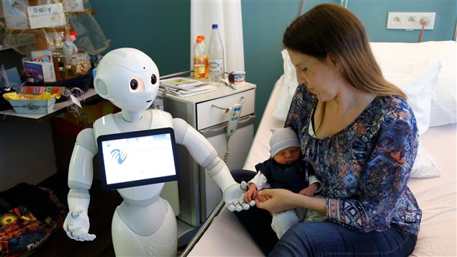   
 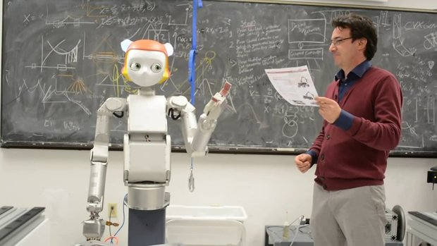­­­­­­­­­­­­­­­­­­­­­­­­­­­­­­­­­­­­­­­­­­­­____________________________________________________________________________

Which tasks are robots more appropriate for?

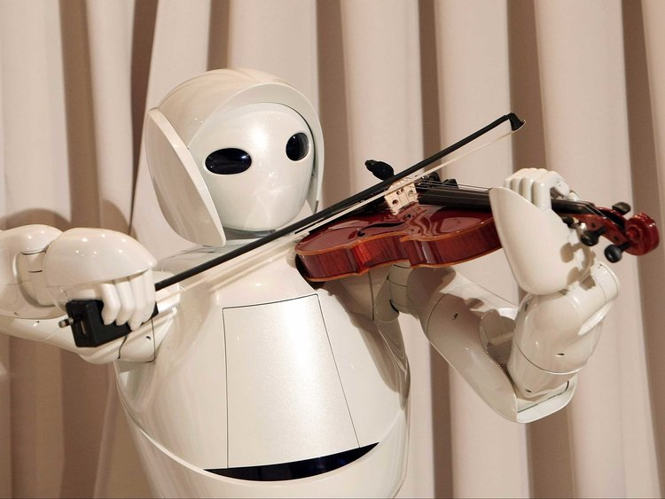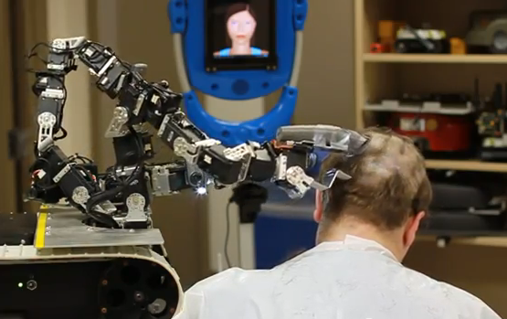

Would you pay to see a robot musician playing or get a haircut by a robot hairdresser? Why?

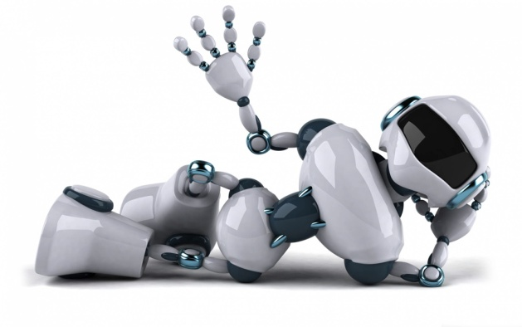**PART 3: Discuss your opinions on these issues:**

- How do you think we should prepare for the arrival of robots in the workplace? Give at least 4 different ideas.

- Do you think introducing robots in the workplace will benefit us or not? Why?

- Do you think it will affect your future job? Why / why not?

- What could we do to minimise the economic and social effects of using robots in the workplace?

- Do you think robots should have ‘rights’ like regular citizens?

Record a **5-minute** summary in which you explain your opinions!